

LEADING ASIA PACIFIC CORPORATE SOLUTIONS PROVIDER
INCORP GROUP PROPOSAL

LAKESHORE INDIA

Table of Contents

- About InCorp Global in India
- Scope of Services
- Commercials with Terms & Conditions

About InCorp
InCorp is a leading provider of a wide range of professional corporate solutions and services across Asia Pacific. We are the only Singapore-based corporate solutions company to have a presence in 9 countries:









SINGAPORE
AUSTRALIA
CHINA
INDIA
INDONESIA
MALAYSIA
PHILIPPINES
VIETNAM
HONG KONG

Our award-winning capabilities and resources provide organisations and individuals a full suite of comprehensive services to help them turn their “Vision To Reality”.

Snapshot
- Pan-Asia player anchored in Singapore
- #1 corporate services provider in Singapore
- Presence across key countries in Asia Pacific region
- 30+ years of operating track record
- Services MNCs, large corporates, SMEs, startups, family offices, funds
- An independent member of PrimeGlobal, an award-winning association of independent accounting and advisory firms



1,200+
Employees
15,000+
Clients

20,000+ Entities
incorporated over the last 10 years

12,000+ Compliance Transactions per year
Strategic Partnerships
with several government entities in Asia, professional firms, fintech firms, accelerators, funds and law firms

1,200+ Employees
across APAC led by professional
management team and industry
experts across multiple disciplines
and platforms

Proprietary in-house Tech
Portal System
which drives industry leading operational and financial metrics

Award-winning Group
and recognized platform in Singapore and Southeast Asia set-up to offer
full suite of comprehensive services
to customers

LOCATIONS
INDIA
1602, B – Wing, One BKC, Bandra Kurla Complex, Mumbai – 400051, India.

VIETNAM
The Galleria Office Building, 258 Nam Ky Khoi Nghia Street, Vo Thi Sau Ward, District 3, Ho Chi Minh City, Vietnam 72408.

HONG KONG
Unit 1307A, 13/F, Two Harbourfront, 22 Tak Fung Street, Hunghom, Kowloon, Hong Kong.

PHILIPPINES
8th Floor, Marajo Tower, 312 26th St. West corner 4th Ave., Bonifacio Global City, Taguig, Philippines 1634.

AUSTRALIA
Level 1, 6-10 O’Connell Street, Sydney NSW 2000, Australia.

MALAYSIA
D-8-3A, Menara SuezCap 1, KL Gateway, 59200 Kuala Lumpur.

SINGAPORE (HQ)
30 Cecil Street, #19-08 Prudential Tower, Singapore 049712.

INDONESIA
AXA Tower 36th floor, Kuningan City, Jl. Prof. Dr. Satrio Kav. 18, Kuningan, Jakarta Selatan 12940, Indonesia.
CHINA
Huamin Hanzun International Building, 726 West Yan’an Road, Changning District, Shanghai

Our Full Range of Corporate Services ACROSS ASIA PACIFIC
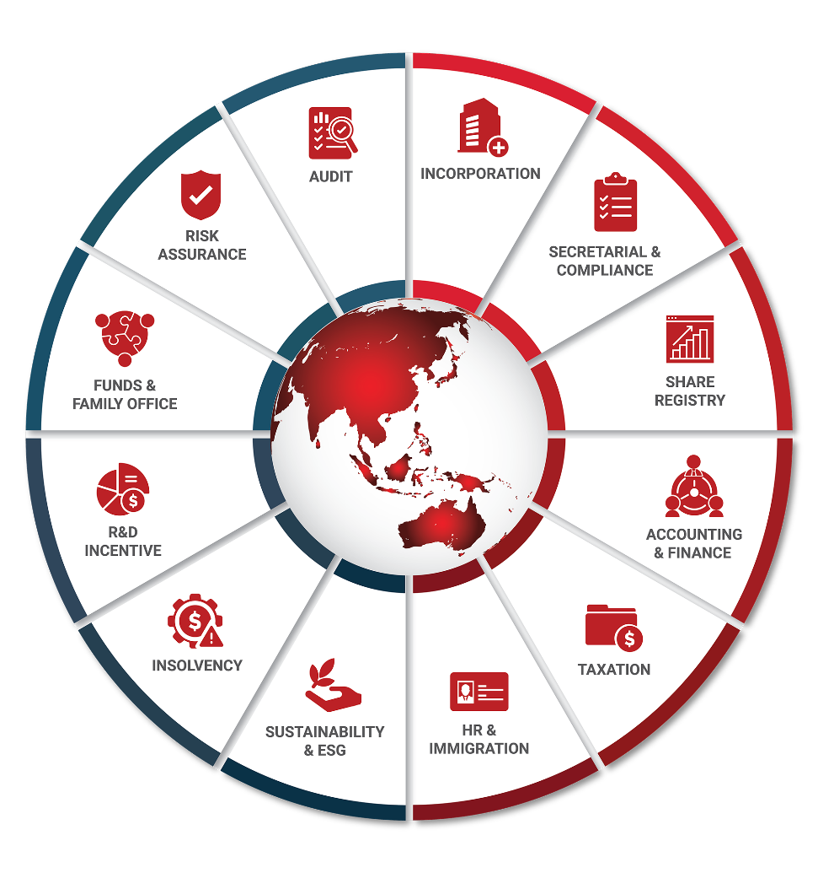

Key Accreditations And Partners

 |  |  | ECONIMIC  DEVELOPMENT  BOARD (EDB) | Connections  Concierge  Partner

ENTERPRISE  SINGAPORE |  |  | MINISTRY OF MANPOWER  (EA - 11C3030) | 

12.03.2026
Mr. Ishwaran Iyer
Lake Shore India Management Private Limited
Unit No. 1611-12, 16th Floor, C Wing, G Block,
One BKC, Bandra Kurla Complex, Bandra (East),
Mumbai City, Mumbai, Maharashtra, India, 400051
Dear Mr. Ishwaran Iyer,

Re: Scope & Proposal for Lake Shore India Management Private Limited- GIFT City Setup & Services

We are pleased to present our proposal to you.

At InCorp (now Ascentium India), we offer turnkey advisory and implementation services for businesses expanding into GIFT IFSC covering entity setup, regulatory licensing, obtaining various registration and supporting ongoing compliance like accounting, tax, regulatory compliances and corporate secretarial services. We support entity covered under various regulations including fund management, capital market intermediaries, fintech, NBFCs, banks, foreign universities and other IFSC-regulated activities.

This proposal outlines our approach to the GIFT IFSC related requirements that you have shared for Lake Shore India Management Private Limited. We trust that it aligns with your expectations, and we look forward to establishing a long-term, mutually beneficial relationship with you and your company.

Yours Sincerely and on behalf of InCorp (India),

Nikhil Joshi
Director Sales- Managed Services
InCorp Advisory Services Pvt. Ltd.

Scope of Services:

Entity Setup Services

- Company/ LLP/ Entity formation with other activities

- Application for name reservation for a setup of proposed entity under Gift City-IFSC (with MCA)
- Identification of office space premise/co-working space in GIFT Special Economic Zone (SEZ) - IFSC
- Liaison to secure a Provisional Letter of Allotment (PLOA) from GIFT – SEZ Developers on finalization of the premise
- Application for incorporation of Company/Limited Liability Partnership entity with MCA, obtaining PAN (Permanent Account Number) and Tax Account Number (WHT)

- SEZ Unit application

- Preparation of documents for SEZ Unit in consultation with the client.
- Preparation of forms, declaration and support documents for IFSCA in consultation with the client.
- Preparation and submission of application online for setting up a unit in FORM FA along with requisite documents.
- Arranging for inclusion of Proposal in Unit Approval Committee agenda.
- Assisting in Interview to your representative for Approval Committee.
- Follow-up for Issuance of Letter of Approval from Development Commissioner, SEZ/ IFSCA (Administrator).
- Preparation and submission of Letter of acceptance of terms and condition within 45 days.
- Regularization of SEZ Online registration with unit and maker creation after payment of registration fees.
- Submission of Application to the concerned regulatory division office of IFSCA.
- Assisting in Interview to your representative for Approval Committee.
- Preparing draft of Query reply, if any, in consultation with the client.
- Assisting in understanding requirements for issuance of final letter of approval from IFSCA.
- Following up for issuance of Letter of Approval (in-principle) from IFSCA.
- Preparing submission along with the relevant documentation for application of letter of approval from IFSCA.
- Arranging for issuance of Letter of Approval (final) from IFSCA.

- Bond-Cum-Legal Undertaking

- Preparation of Application for Bond cum legal undertaking with annexure in consultation with the legal advisor.
- Submission of Bond cum Legal Undertaking to Specified Officer for procurement of Duty-free Goods.
- Getting the BLUT accepted from Specified officer of the SEZ.
- Submission of the duly accepted BLUT to the Development Commissioner office in physical as well on SEZ Online.
- Obtaining approval for BLUT from Development Commissioner office/ IFSCA (Admin).
- Obtaining Eligibility certificate for exemption

- Preparation of application for obtaining eligibility certificate.
- Submission of the same to the Development Commissioner office.
- Obtaining approval for eligibility certificate.

- Obtaining Import Export Code registration

- Providing detailed checklist of documents required for obtaining IEC Code in new entity name.
- Preparation and filing of application online.
- Submission of the same to respective authorities.
- Obtaining allotment of IEC code.

- Obtaining GST registration

- Providing detailed checklist of documents required for obtaining GST registration in new entity name.
- Preparation and filing of application online.
- Submission of the same to respective authorities.
- Obtaining GST registration.

- Obtaining RCMC

- Providing detailed checklist of documents required for obtaining RCMC.
- Preparation and filing of application online.
- Submission of the same to respective authorities.
- Follow up for obtaining RCMC.

- FIU (Financial Intelligence Unit) Registration

- Providing a detailed checklist of documents required for FIU registration under the Prevention of Money Laundering Act (PMLA).
- Preparation and filing of the online FIU registration application on the regulatory gateway in prescribed format.
- Submission of documents to FIU-IND, coordination with FIU officials, and follow-up for obtaining the FIU registration credentials (FINnet login ID, reporting entity code, etc.).

- Professional Tax Registration (PTEC & PTRC)

- Providing a checklist of documents required for obtaining Professional Tax Enrolment Certificate (PTEC) and Professional Tax Registration Certificate (PTRC).
- Preparation and online filing of applications for PTEC and PTRC with the Commercial Tax Department, along with supporting annexures. Liaison with the authorities for verification, addressing clarifications, and obtaining approvals for PTEC and PTRC registrations.

Other Support Services (Optional)

- Assistance in preparation of projections and business plan

- Collating the information on the promoters of the group.
- Collating the information on the background group.
- Collating the information on the directors/KMP of the entity.
- Preparing the presentation on the business operations based on inputs provided.
- Preparing the presentation of organizational chart based on inputs provided.
- Preparing the presentation of business plan based on inputs provided.

- Support on application of commencement of operations in SEZ/IFSCA

- Issuance of share certificates in compliance with MCA requirement.
- Assistance in company secretarial compliance for conducting 1st Board meeting as per companies Act.
- Preparation of documentation required and filing of Stat. Auditor appointment with MCA (if applicable)
- Preparation and processing of Letters of Acceptance with SEZ department.
- Preparation of application for commencement of operation before SEZ in coordination with legal advisors.
- Preparation of application for commencement of operation before IFSCA in coordination with legal advisors.
- Assistance in the registration process with the Financial Intelligence Unit Portal to ensure compliance with KYC, AML-CFT regulations.
- Regularization of SEZ portal with unit and maker creation after payment of registration fees.

- Liaison for Bank Account opening (Foreign currency account and INR account)

- Draft all necessary forms required for account opening and related transactions with Bank.
- Ensure accuracy and completeness of information in the forms, adhering to the bank's specifications.
- Collaborate and collate all Know Your Customer (KYC) documents required by Bank for account opening and other transactions.
- Verify that all submitted documents meet the bank's KYC requirements and standards.
- Guide and assist the client in completing the account opening process with Bank.
- Act as an intermediary between the client and Bank in resolving any queries, concerns, or clarifications related to account opening, transactions, or other banking matters.
- Provide guidance to the client on the documentation required by Bank and assist in obtaining any additional information needed.

- Assisting in additional capital infusion (to meet regulatory requirements)

- Preparing of relevant set of documents for holding Board meeting with agenda to increase authorized capital.
- Preparing of relevant set of documents for holding Shareholder’s meeting (EGM) with agenda to increase authorized capital.
- Preparation and filing of relevant forms on MCA portal.
- Assistance in payment of MCA fees & other stamp duty etc.

- ICEGATE Registration

- Providing a detailed checklist of documents required for registration on the Indian Customs Electronic Gateway (ICEGATE) portal for facilitating import/export transactions.
- Preparation and Filing of the application on the ICEGATE portal, coordination with customs authorities, and follow-up for verification and approval of registration.

- Shop & Establishment Intimation/Registration.
- Providing a detailed checklist of documents required for registration / intimation for Shop & Establishment.
- Filing of the application, coordination with concerned authorities, and follow-up for verification and letter of approval/intimation.

- Obtaining SEZ ID cards
- Preparation and submission of applications for SEZ ID cards through the relevant SEZ online/offline portal.
- Coordination with the SEZ administration / Development Commissioner’s office for processing of the applications.
- Follow-ups and assistance until issuance of the SEZ ID cards for the approved personnel.

Commercials with terms & conditions:

No. | Scope | Fees (USD)
1. | Entity Setup Services | 5,000
2. | Other Support Services (Optional Services)
 | 2(a) to 2(d) | 750 per service
 | 2(e) to 2(g) | 750 (lumpsum)
Note:
- All Fees quoted are exclusive of applicable GST and do not include any out-of-pocket expenses charged at actuals.
- Fees exclude expenses related to any government/statutory filing fees, levies and taxes.



Contact Details
Meet Thakkar
Head – GIFT IFSC Practice
meet.thakkar@incorpadvisory.in
(+91) 98705 48828
Nikhil Joshi
Director Sales – Managed Services
nikhil.joshi@incorpadvisory.in
(+91) 99600 59498
InCorp Advisory Services Pvt. Ltd.

Mumbai Office:
B-1602, One BKC, Bandra Kurla Complex,
Mumbai – 400051.

Website: https://incorpadvisory.in/ | https://www.incorp.asia/




FOLLOW US ON:

Copyright ©2026 INCORP ADVISORY SERVICES PRIVATE LIMITED
All rights reserved.

